**FPGA Karaoke**

A Final Project Proposal for ECE383

By

C2C Mark A. Demore II

March 15, 2018

1. **Objective**:

The purpose of this system is to take an audio input and strip out the vocals, display an FFT of the audio and output it through a speaker, along with input from a microphone. Some additional functionality may be to match microphone input with the stripped vocals to measure accuracy.

1. **Technical Requirements:**

The voice stripper must remove all main vocals or reduce main vocals to a negligible level in comparison to instrumentals (Basic Functionality). The FFT must display the full range of the input audio (B-Functionality). Switches will turn voice stripping and the microphone source on and off (A-Functionality).

1. **Top Level Design:**

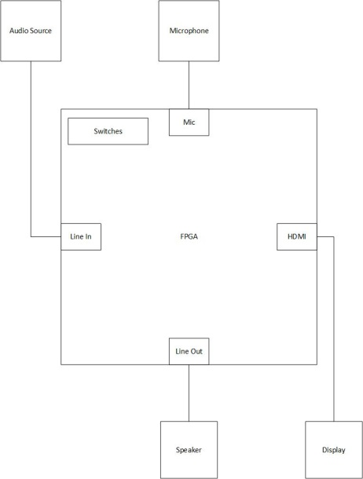

|  |  |
| --- | --- |
| Module | Nexys Video FPGA |
| Inputs | On-board switches, audio source via aux Line In, Microphone |
| Outputs | Display via HDMI, Speaker via aux Line Out |
| Behavior | Voice stripping, audio FFT display, switches used to modify audio out to include enable/disable voice stripping and microphone audio |